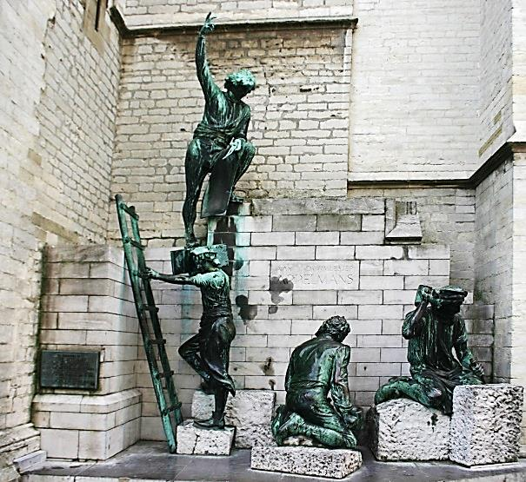
Master Builder Award Program
Builders are people who “construct something by putting parts or material together over a period of time.” By fulfilling the requirements of the Grand Lodge of Maine “Master Builder Award,” Masons will undertake a forward looking assessment of their Lodge and its needs / opportunities. They will engage and lead Brethren in building a stronger Lodge, as evidenced by: greater member and visitor participation in Lodge meetings and activities; increased member understanding and practice of the tenets and purposes of Freemasonry; and more bountiful service to the Craft, the community and society.
A minimum of ten items need to be fulfilled for a Mason to earn the Master Builder Award. The requirements accentuate Freemasonry’s purpose as perhaps stated best by President and Wor. Bro. George Washington: “The grand object of Masonry is to promote the happiness of the human race.” The work of Grand Lodge, the Masonic Charitable Foundation, our Lodges and every Brother should be towards that end.
Monument to “Master Builders” at the Ca-thedral of our Lady in Antwerp, Belgium. It honors the builders of the Temple, construction of which started in 1352.
There is no time limit for accomplishing these important undertakings. The intent of the Masonic Rookie Award is to encourage new Masons to quickly build both ties to their fraternity and a basic understanding of its operations – to build a cord not easily broken. The Master Builder Award seeks to engage Brethren of all levels of Masonic experience to envision, plan and undertake initiatives that will broadly strengthen his Lodge and the fraternity. Activities begun in 2016 and subsequent years may be considered towards achieving the requirements of this prestigious recognition of personal achievement in Freemasonry.
Lodges will submit a report to the Grand Master detailing what the award nominee has undertaken and achieved to satisfy the required and optional award requirements. The submission, likely prepared by the nominee and certified by the Lodge Master or Secretary, should fully describe his actions and document how they have benefited the Lodge, its community(s) and society. The package might include a copy of the Masonic Excellence paperwork, documentation on fellowship nights, Bikes for Books presentations, and pictures of events held and projects undertaken. Master Builders will receive an impressive award during an upcoming Annual Communication of Grand Lodge or other venue determined by the Grand Master.

REQUIRED: Lodge Involvement
- Participate in at least seven stated / special Lodge communications each year while pursuing the Master Builder Award.
- Personally sponsor at least one accepted candidate for the degrees.
- Lead the planning and completion of a material Lodge / building association improvement project as contained in the Lodge’s Masonic Excellence Award plan or of a similar project as otherwise approved by the Lodge.
- Strengthen brotherhood outreach: assist and / or visit at three Lodge members, or their widows, and other Brethren living locally (who are not personal relatives) to provide comfort and renew Masonic ties, urge engagement with the Lodge, or undertake projects to address their urgent personal needs.

OPTIONAL
Part 1 – Establishing the future direction and vitality of the Lodge. (complete any two of the following)
- Lead or arrange for the facilitation of a Lodge discussion of how it wants to be perceived by the Lodge Brethren and the community(s) served by the Lodge – how it will add value and enrich lives.
- Organize and lead a discussion of the Constitutional requirements pertaining to a Lodge and an assessment of how the Lodge fulfills the expectations of Chartered Lodges (and building associations).
- Prepare and lead (arrange for the facilitation of) a discussion of the precepts and core values of Freemasonry and how the Lodge measures itself in comparison to those values. (See #5 above.)
- Lead the development and completion of a Masonic Excellence Award submission for your Lodge.
Part 2 – Strengthening Lodge membership, governance and activities. (complete any two)
- Organize / cosponsor a Lodge / multi-Lodge fellowship event that attracts at least five prospective applicants for Freemasonry.
- Lead / coordinate one of the following Lodge approved activities: widows’ event; Bikes for Books program; child service initiative; community betterment activity; or, the formation / rejuvenation of a local DeMolay Chapter or Rainbow Assembly.
- Lead a review and update of the Lodge’s Bylaws, including its membership dues and degree fee structures.
- Lead a review (or audit) of the Lodge’s / Lodge hall’s annual expenses (budget) and initiate actions to assure the adequacy of the Lodge’s dues structure and fundraising activities in funding a vibrant Lodge that provides value to its members, their families and communities.
- Organize and lead an annual / special purpose fundraising event to support the Lodge or its charitable / community outreach initiatives and to best employ funding available from the Masonic Charitable Foundation, if applicable.
Part 3 – Personal development (complete any two)
- Participate in three Maine Masonic College or Grand Lodge sponsored educational opportunities. (Completion of a Maine Masonic College certificate program will qualify for fulfilling any two OPTIONAL requirements.)
- Represent the Lodge at three or more meetings of the District membership association and actively assist on one District project.
- Deliver well the lecture from at least one of the three Masonic degrees.
- Mentor a candidate in the three prescribed degree lessons, including the meaning of the symbolism of the degrees, and work with him to achieve the Masonic Rookie Award.

The underlying premise: There are many Brothers in our Lodges who are looking to engage in Masonic activities. There are also Brothers who have not returned to Lodge in some time (or even completed their degrees). The Master Builder Award will benefit a concerted effort by the Worshipful Master and other officers to strengthen the Lodge and reconnect with these Brothers, to pique their interest and get them coming out once again. An active Lodge is a strong Lodge; active Masonic Builders will be the cornerstone of a strong foundation for our personal and fraternal Masonic edifice.
Master Builder Award Nomination
Name of Nominee: | Lodge:
Telephone No: | Email:

Criteria No: | Brief Criteria description:
Describe what was undertaken, how the nominee was involved, and how the initiative has benefited Freemasonry, the Lodge, its Brethren and community(s) and society:

Date completed: |  | Project certification – signature of Master or Secretary:

Criteria No: | Brief Criteria description:
Describe what was undertaken, how the nominee was involved, and how the initiative has benefited Freemasonry, the Lodge, its Brethren and community(s) and society:

Date completed: |  | Project certification – signature of Master or Secretary:

Criteria No: | Brief Criteria description:
Describe what was undertaken, how the nominee was involved, and how the initiative has benefited Freemasonry, the Lodge, its Brethren and community(s) and society:

Date completed: |  | Project certification – signature of Master or Secretary:

Criteria No: | Brief Criteria description:
Describe what was undertaken, how the nominee was involved, and how the initiative has benefited Freemasonry, the Lodge, its Brethren and community(s) and society:

Date completed: |  | Project certification – signature of Master or Secretary:

Criteria No: | Brief Criteria description:
Describe what was undertaken, how the nominee was involved, and how the initiative has benefited Freemasonry, the Lodge, its Brethren and community(s) and society:

Date completed: |  | Project certification – signature of Master or Secretary:

Criteria No: | Brief Criteria description:
Describe what was undertaken, how the nominee was involved, and how the initiative has benefited Freemasonry, the Lodge, its Brethren and community(s) and society:

Date completed: |  | Project certification – signature of Master or Secretary:

Criteria No: | Brief Criteria description:
Describe what was undertaken, how the nominee was involved, and how the initiative has benefited Freemasonry, the Lodge, its Brethren and community(s) and society:

Date completed: |  | Project certification – signature of Master or Secretary:

Criteria No: | Brief Criteria description:
Describe what was undertaken, how the nominee was involved, and how the initiative has benefited Freemasonry, the Lodge, its Brethren and community(s) and society:

Date completed: |  | Project certification – signature of Master or Secretary:

Criteria No: | Brief Criteria description:
Describe what was undertaken, how the nominee was involved, and how the initiative has benefited Freemasonry, the Lodge, its Brethren and community(s) and society:

Date completed: |  | Project certification – signature of Master or Secretary:

Criteria No: | Brief Criteria description:
Describe what was undertaken, how the nominee was involved, and how the initiative has benefited Freemasonry, the Lodge, its Brethren and community(s) and society:

Date completed: |  | Project certification – signature of Master or Secretary:

Date submitted to the Grand Master: | Brother submitting completed nomination:

