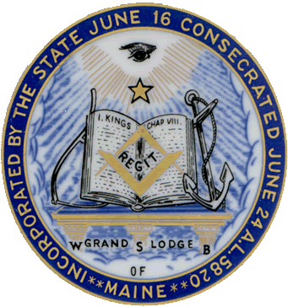
Grand Lodge of Maine, A.F.&A.M.
1007 Maine Road / PO Box 430, Holden, ME 04429-0430
Tel: (207) 843-1086 / Fax: (207) 843-1088
www.MaineMason.org

Office of the Grand Lecturer
R.W. Harland Harnden
104 Bryant Road, Wilton, ME 04294

Request for Approval to Perform Ritualistic Work

To the Grand Master of the Grand Lodge of Maine:

This will acknowledge our receipt and understanding of the Order dated August 2, 1954 (directive read prior to the second section), concerning the conferring of ritualistic instruction and degrees in the Masonic Lodges of the State of Maine.

As an organization, we agree to conform to both the letter and spirit of the Order, and respectfully request approval by the Grand Lecturer for authority to perform ritualistic work, as outlined in the Order.

We furthermore understand that said approval by the Grand Lecturer may be withdrawn at any time, as it is granted only with the understanding that all so-called visiting Degree Teams will comply with the Order, strictly and completely.

This certified team agrees to confer no more than one Degree in any Lodge during any calendar year.

Approved:
Signed

Address
Grand Lecturer
City

State
Assistant Grand Lecturer
For the Following Organization
Date:

Valid until: My Title or Rank is

Director of Work, Ritual Master, etc.

