Grand lodge of maine a.f. & a.m.

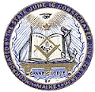

DISTRICT DEPUTY
MANUAL

Revised 2001 by:

Masonic Education & Lodge Service Committee

Peter M. Baker
Richard L. Bowden
Howard B. Ellis
George M.A. Macdougall
Walter M. Macdougall, P.G.M.
Kenneth C. Mitchell
David A. Walker, chairman

Wayne T. Adams, Grand Master

