Master Builder Award

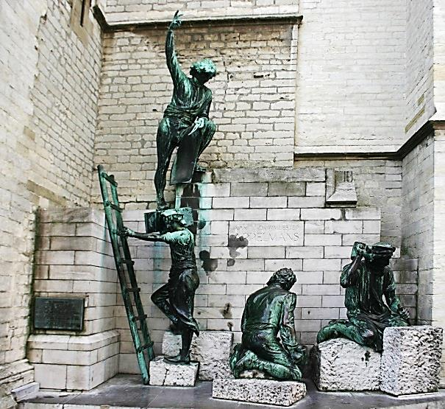
Our Lodges are populated with men all of whom have a unique set of gifts and talents derived from their creation, life experiences, and growth within Freemasonry. While we expect that all Brothers will use these gifts and talents to improve their lives and the presence of Freemasonry in their Lodge and community, there are those Brothers that go above and beyond these expectations.

The Master Builder Award is designed to allow the Lodges to seek statewide recognition for these exceptional Brothers. This award allows a Lodge, through its Master, to nominate a Brother to receive this recognition. The nominations will be reviewed by the Grand Master who will determine the recipients of the Award at each Annual Communication.

Criteria for consideration are as follows:

- The Brother must have at least 10 continuous years of service in the Craft.

- The Brother must have regularly attended the meetings of his Lodge during that period.

- The Brother must have served in various line Offices including Master for one year; and/or
Provided ancillary services related to the smooth operation of the Lodge; and/or
Been instrumental in successful Lodge programs in the community, Lodge fund raising activities, and/or Lodge outreach efforts which portrayed the Lodge in a positive light in the community it serves.

The Lodge may nominate a Brother to receive this award by sending a nominating letter to the Grand Master stating the Brother’s qualifications as they relate to the criteria listed above. The letter should be signed by the Master of the Lodge and contain the signature of the Secretary certifying the positive vote of the Lodge. Nominations must be received no later than March 1st to be considered for the following Annual Communication.

